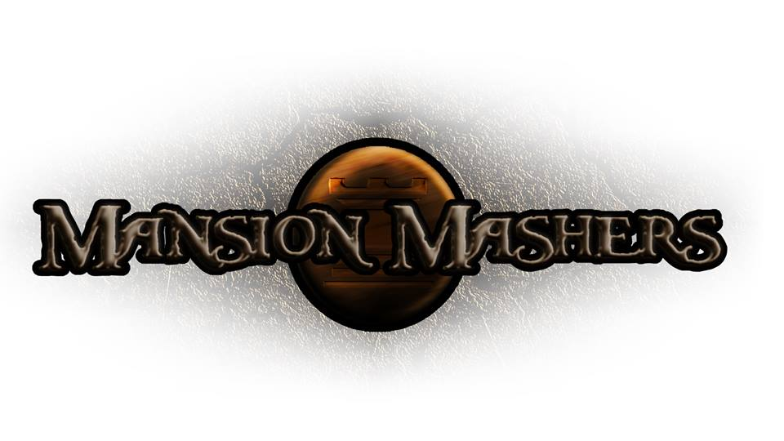**Weekly Production Report**

**Week 6**

**February 13, 2014**

**By Juli Gregg**

**High Concept**:

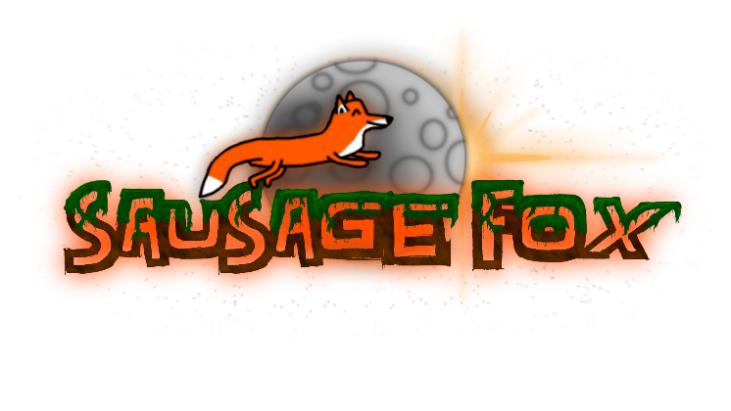A 2-D fast-paced, side scrolling hack and slash game set in a cartoon fantasy world with character ability progression.

**Producer:**

Juli Gregg

**Tech Director**:

Dan Muller

**Game Designer**:

Luke Conlon

**Project Manager**:

Kaden Nugent

Project Status:

Green

Current Milestone:

Engine Proof

Accomplishments:

|  |  |
| --- | --- |
| **Juli Gregg:** | Mapped out five levels on paper. Completed PPD. Created Presentation materials. Implemented a Sound Manager. Worked on tutorial background. |
| **Dan Muller:** | Created enemy type, slide show setup in Engine for presentation, weapon pop-up text, text alignment options, resizing hover text, and added boxes around aspect ratio. Completed TDD. Implemented a working Tutorial Level. Bug fixes. Added weapon to enemy collision. |
| **Luke Conlon:** | Mapped out five levels on paper. Created a particle system. Fixed player ‘swing weapon’ animation. Designed ‘dummy’ for tutorial and particle art for ‘poofs’ and hay. |
| **Kaden Nugent:** | In the process of testing Memory Manager. Worked on tutorial background. |

Objectives:

|  |  |
| --- | --- |
| **Juli Gregg:** | Map out more levels on paper as well as begin to layout game objects/platforms in engine. Test Sound Manager. Create level backgrounds. |
| **Dan Muller:** | Work on implementing boss mechanics and implement code for features needed in new levels. Bug Fixing. |
| **Luke Conlon:** | Map out levels and begin working on Enemy/Boss logic. Continue to create art assets. Improve Particle System. |
| **Kaden Nugent:** | Work on improving Collision Manager and implement an Enemy Manager. |

Group Accomplishments:

|  |  |
| --- | --- |
| **Weekly Group Meeting** | Together we went through and mapped out a timeline to be explained in the PPD. Generated a list of Sound Assets including background music, effects, and voice overs we need. Discussed Menu layouts and design. |
| **Repository**  **Commit Stats** | This week: 84 commits  In a month: 347 commits |

Group Objectives:

|  |  |
| --- | --- |
| **Weekly Group Meeting** | Reflect on feedback from Engine Proof. Identify what components we may want to improve. |

Highlights:

We hit a couple of bumps in the road this week with Dan’s laptop being fried, but everyone is proud of and excited to show off our tutorial for Engine Proof.

Risks & Mitigations:

|  |  |
| --- | --- |
| **RISKS:** | (1) We have a lot of plans for this game that due to limited amount of time we may not be able to implement everything that we want to.  (2) The workload from other classes has begun to add up and has allowed for less time to work on game.  (3) Dan’s laptop was fried by his power cord.  (4) We are having trouble finding areas to work together within DigiPen with reliable internet. |
| **MITIGATIONS:** | (1) Attempt to keep a realistic timeline and slowly weave in stretch goals as we achieve the basic requirements to make our game functional and fun.  (Ex. Multiplayer)  (2) Since we planned out our schedules together we are able to help one another and work more efficiently to get assignments done.  (3) We found someone who was able to let us borrow their secondary laptop for a few weeks while Dan’s gets fixed.  (4) We have addressed our concerns to Mark Ward in student affairs who also plays a role in Student Senate. |

**Signatures**

_____________________

Juli Gregg

_____________________

Dan Muller

_____________________

Luke Conlon

_____________________

Kaden Nugent